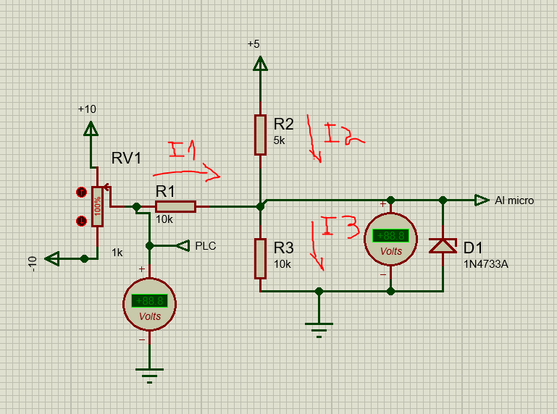
$I_{1}+ I_{2}= I_{3}$ $$I_{1}+ I_{2} {- I}_{3 }=0$$
$$\frac{V_{IN}- V_{out}}{10K} + \frac{5V - V_{out}}{5K}- \frac{V_{out}}{10K}=0$$
$$V_{IN}- V_{out}+10V-2V_{out}- V_{out}=0$$
$$V_{IN}+10V=4V_{out}$$
$$V_{out}= \frac{V_{in}+10V}{4}$$

